Stage 5 Lab: Refactoring SmartCare into a Layered Architecture

A – Inspect SmartCare v0.4

1. Current Problem
In SmartCare System there are several responsibilities which are mixed together. Appointment-related code may currently handle:
- User input and display
- Workflow of the appointment
- Enforcing the business appointment rules
- Saving and retrieving appointment data in system
This makes the system complex which makes it harder to maintain and test because one part of the application is responsible for several different concerns of the system.

2. Responsibility Analysis
Responsibility | Current Mixed Location | Correct Layer
Display the appointment | Appointment/UI code | Presentation
Receive user actions | Appointment/UI code | Presentation
Coordinate the workflow of appointment | Appointment/UI code | Service
Decide the status of the appointment | Appointment-related logic | Domain
Enforcing the business rules in the appointment | Appointment class | Domain
Save appointments | Appointment/UI or application code | Repository/Persistence
Retrieve appointments | Appointment/UI or application code | Repository/Persistence
Store data in database/file | Data-access code | Persistence

B –

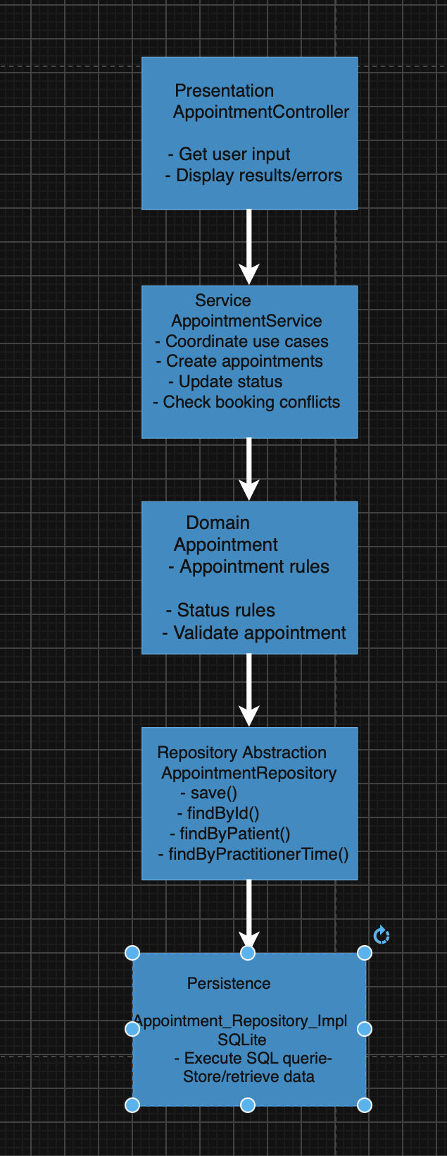

Dependency Direction
The dependency direction should be:
Presentation → Service → Domain

C – Package Structure
A simple package structure is:
smartcare/
│
├── domain/
│ └── Appointment
│
├── services/
│ └── AppointmentService
│
├── repositories/
│ └── AppointmentRepository
│
├── persistence/
│ └── AppointmentRepositoryImpl
│
└── presentation/
└── AppointmentController

Responsibilities
domain/
Contains the business rules of the SMART CARE.
services/
Coordinates appointment workflow in the system and the use cases.
repositories/
Contains abstractions for accessing appointment data in the system.
persistence/
Contains the actual implementation for storing and retrieving data.
presentation/
Handles user interaction and presentation of results.

D – Introduce AppointmentService
The AppointmentService should coordinate the workflow of the appointment in the system. It should not take away the business behaviour from the appointment domain class

Appointment Domain
The appointment object remains responsible for its own business behaviour.
For example:
Appointment
- patient
- practitioner
- date
- time
- status

+ changeStatus()
+ validate()

AppointmentService
The service coordinates the use case:
AppointmentService
+ createAppointment()
+ updateAppointmentStatus()
+ getAppointmentHistory()

Responsibility Split
Component | Responsibility
Appointment | Appointment data and business rules
AppointmentService | Coordinates appointment workflows
AppointmentRepository | Defines required appointment data operations
AppointmentRepositoryImpl | Performs actual data storage/retrieval
Presentation | Handles user interaction

E – Repository Abstraction
The repository should contain only the operations currently required by SmartCare’s appointment use cases.

AppointmentRepository
interface AppointmentRepository {

save(appointment)
findById(id)
findByPatient(patientId)
findByPractitionerAndDateTime(practitionerId, dateTime)
}

Why These Methods?
- save () is required to store appointments.
- findById() allows an existing appointment to be retrieved.
- findByPatient() supports appointment history.
- findByPractitionerAndDateTime() supports duplicate-booking prevention.
The repository should not contain unrelated methods such as:
sendReminder()
calculatePayment()
diagnosePatient()
generateMarketingReport()
Those operations are outside the current appointment repository use cases.

Persistence Implementation
The persistence layer implements the repository contract:
AppointmentRepositoryImpl
implements
AppointmentRepository
For example:
save(appointment)
→ store appointment in database/file

findById(id)
→ retrieve appointment

findByPatient(patientId)
→ retrieve patient's appointments

findByPractitionerAndDateTime(practitionerId, dateTime)
→ retrieve conflicting appointment
The service therefore does not need to know whether SmartCare uses a database, file or another storage mechanism.

F – AI Architecture Review

AI Review Prompt
Act as a software architecture reviewer. Review the proposed SmartCare layered architecture consisting of Presentation → Service → Domain, with AppointmentService using an AppointmentRepository abstraction implemented by the persistence layer. Review dependency direction, misplaced responsibilities, coupling, unnecessary complexity and testability. Do not invent new business requirements. Recommend only the simplest justified improvements based on the existing SmartCare requirements and architecture. For every suggestion, state whether it is evidence-based or requires validation.

AI Review Results
AI Suggestion | Evidence? | Proposed Decision
Presentation should not directly access persistence. | Evidence-based | Accept
AppointmentService should coordinate workflows rather than contain all business rules. | Evidence-based | Accept
AppointmentRepository should remain a small interface. | Evidence-based | Accept
Persistence should implement the repository abstraction. | Evidence-based | Accept
Appointment business rules should remain in Appointment. | Evidence-based | Accept
Add a separate Unit of Work layer. | No | Reject
Add a separate Factory layer. | No | Reject
Add multiple services for every possible future feature. | No | Defer
Add DTOs immediately. | No | Defer
Add dependency injection framework. | Not currently necessary | Defer

G – Refactor and Verify

Refactoring Changes
The following changes are applied:

Change 1 – Move Workflow to AppointmentService
Appointment workflow coordination is moved out of presentation code and into:
AppointmentService

Change 2 – Introduce Repository Abstraction
Data access is separated using:
AppointmentRepository
The service depends on this abstraction rather than directly accessing storage.

Change 3 – Separate Persistence
Actual storage operations are placed in:
AppointmentRepositoryImpl
inside the persistence/ package.

Change 4 – Keep Domain Behaviour in Appointment
The Appointment entity retains its own business rules.
The service does not take ownership of domain decisions unnecessarily.

Verification
After refactoring, the existing SmartCare behaviour should remain unchanged.
Existing Behaviour | Verification
Create appointment | Pass – service coordinates creation and repository saves it.
Prevent duplicate booking | Pass – service checks repository before saving.
Update appointment status | Pass – Appointment retains status behaviour.
View appointment history | Pass – repository retrieves appointments by patient.
Retrieve appointment | Pass – repository provides retrieval operation.
Store appointment information | Pass – persistence implementation handles storage.

Architecture Verification
Presentation → AppointmentService → Domain
↓
AppointmentRepository
↑
Persistence Layer
There is no requirement for the domain to directly access persistence.
Therefore:
- Presentation does not contain database code.
- Service contains workflow coordination.
- Domain contains appointment behaviour.
- Repository defines data-access needs.
- Persistence performs actual storage.
- Existing appointment behaviour is retained.

H – Reflection
The AI architecture review identified several useful improvements for the systems but the suggestions need to be tested and been checked before implementing them in the system. One suggestion I accepted was keeping persistence access behind the AppointmentRepository abstraction. This improves the concerns of the coupling in the system and reduce the complexity of the system because AppointmentService does not need to know how appointment data is stored.
One suggestion that I have modified from the AI review was the recommendation to keep the AppointmentService focused on workflow coordination. I accepted the suggestion but ensured that business rules remained inside the Appointment domain object. This prevents the service from becoming responsible for all appointment behaviour.
One suggestion I rejected/deferred was adding additional architectural layers such as a Unit of Work or Factory. These could increase complexity of the current SmartCare requirements and make it hard to understand and test. The assignment asks for a small, maintainable system, so additional patterns should only be introduced when there is evidence that they are needed.
The refactoring was verified by checking that existing behaviour, including appointment creation, duplicate-booking prevention, status updates and appointment history, remains available. The main improvement is therefore the separation of the responsibilities of system , rather than adding new functionality.

